|  |
| --- |
| 1. Create a VB.NET application to maintain information of Medicine in following table. (March/April2018) tblMedicine (MID, Name, Type[tablet, capsule, syrup], company, rate) Perform Insert, Delete and Update operations on it and also generate report in data gridview for those medicine which are syrup and rate less than 500 |

Imports System.Data.SqlClient

Public Class Form1

Dim cmd As New SqlCommand

Dim cn As New SqlConnection

Private Sub Form1_Load(ByVal sender As System.Object, ByVal e As System.EventArgs) Handles MyBase.Load

Try

cn.ConnectionString = "Data Source=.\SQLEXPRESS;AttachDbFilename=C:VBNET\Practical\p1\p1\Database1.mdf;Integrated Security=True;User Instance=True"

cmd.Connection = cn

Catch ex As Exception

MsgBox(ex.Message)

End Try

display()

End Sub

Private Sub Button1_Click(ByVal sender As System.Object, ByVal e As System.EventArgs) Handles Button1.Click

Try

Dim type As String

If chkTablet.Checked Then

type = chkTablet.Text

End If

If chkCapsule.Checked Then

type = type + chkCapsule.Text

End If

If chkSyrup.Checked Then

type = type + chkSyrup.Text

End If

cmd.CommandText = "insert into tblMedicine values('" + txtMid.Text + "','" + txtName.Text + "','" + type + "','" + txtCompany.Text + "'," + txtRate.Text + ")"

cn.Open()

cmd.ExecuteNonQuery()

cn.Close()

Catch ex As Exception

MsgBox(ex.Message)

End Try

display()

End Sub

Sub display()

cmd.CommandText = "select * from tblMedicine where Rate < 500"

Dim ad As New SqlDataAdapter(cmd)

Dim dt As New DataTable

ad.Fill(dt)

DataGridView1.DataSource = dt

End Sub

Private Sub Button2_Click(ByVal sender As System.Object, ByVal e As System.EventArgs) Handles Button2.Click

Dim type As String

Try

If chkTablet.Checked Then

type = chkTablet.Text

End If

If chkCapsule.Checked Then

type = type + chkCapsule.Text

End If

If chkSyrup.Checked Then

type = type + chkSyrup.Text

End If

cmd.CommandText = "update tblMedicine set name = '" & txtName.Text & "' where mid = " & txtMid.Text & ""

cn.Open()

cmd.ExecuteNonQuery()

cn.Close()

Catch ex As Exception

MsgBox(ex.Message)

End Try

display()

End Sub

Private Sub Button3_Click(ByVal sender As System.Object, ByVal e As System.EventArgs) Handles btndelete.Click

Try

cmd.CommandText = "delete from tblMedicine where mid = " & txtMid.Text & " "

cn.Open()

cmd.ExecuteNonQuery()

cn.Close()

Catch ex As Exception

MsgBox(ex.Message)

End Try

display()

End Sub

End Class

Output:===

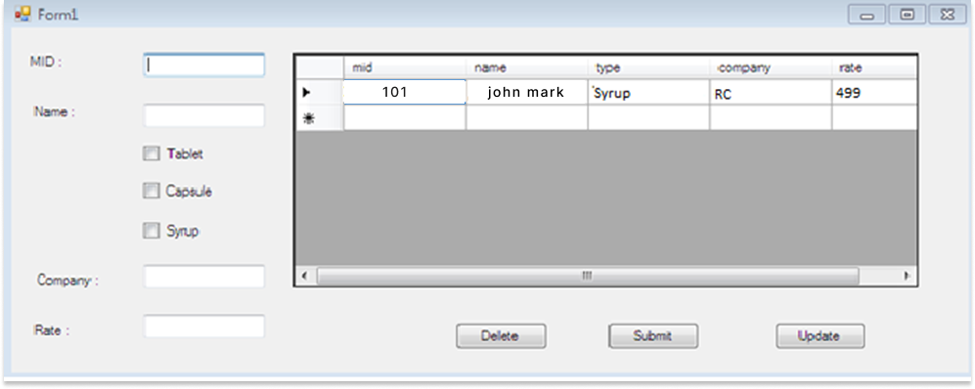

|  |
| --- |
| 1. Create VB.NET application to maintain Products Information. Create following table:Tblproduct(pno,pname,qty,cost_price,sell_price) Perform Insert, Delete and Update operations on it and also generate report in data gridview for those pno whose cost_price is less than sell_price. |

ImportsSystem.Data.SqlClient

Public ClassForm1

Dim con AsNewSqlConnection

DimcmdAsNewSqlCommand

Private Sub Form1_Load(ByVal sender AsSystem.Object, ByVal e AsSystem.EventArgs) Handles MyBase.Load

Try

con.ConnectionString = "Data Source=.\SQLEXPRESS;AttachDbFilename=C:VBNET\Practical\p2\p2\Database1.mdf;Integrated Security=True;User Instance=True"

cmd.Connection = con

Catch ex AsException

MsgBox(ex.Message)

End Try

DisplayData()

End Sub

Sub DisplayData()

Try

cmd.CommandText = "select * from tblProduct"

Dim da AsNewSqlDataAdapter(cmd)

Dim dt AsNewDataTable

da.Fill(dt)

DataGridView1.DataSource = dt

Catch ex AsException

MsgBox(ex.Message)

End Try

End Sub

Private Sub btninsert_Click(ByVal sender AsSystem.Object, ByVal e AsSystem.EventArgs) Handles btninsert.Click

Try

cmd.CommandText = "insert into tblProduct values("&txtpno.Text&" , '"&txtpname.Text&"' , "&txtqty.Text&" , "&txtcostprice.Text&" , "&txtsellprice.Text&")"

con.Open()

cmd.ExecuteNonQuery()

con.Close()

MsgBox("Data Sucessfully Inserted…..")

Catch ex AsException

MsgBox(ex.Message)

End Try

DisplayData()

End Sub

Private Sub btnupdate_Click(ByVal sender AsSystem.Object, ByVal e AsSystem.EventArgs) Handles btnupdate.Click

Try

cmd.CommandText = "update tblProduct set Pname='"&txtpname.Text&"' , QTY="&txtqty.Text&" , CostPrice="&txtcostprice.Text&" , SellPrice="&txtsellprice.Text&" where PNo="&txtpno.Text&" "

con.Open()

cmd.ExecuteNonQuery()

con.Close()

MsgBox("Data Sucessfully Updated…..")

Catch ex AsException

MsgBox(ex.Message)

End Try

DisplayData()

End Sub

Private Sub btndelete_Click(ByVal sender AsSystem.Object, ByVal e AsSystem.EventArgs) Handles btndelete.Click

Try

cmd.CommandText = "delete tblProduct where PNo="&txtpno.Text&" "

con.Open()

cmd.ExecuteNonQuery()

con.Close()

MsgBox("Data Sucessfully Deleted…..")

Catch ex AsException

MsgBox(ex.Message)

End Try

DisplayData()

End Sub

End Class

Output:===

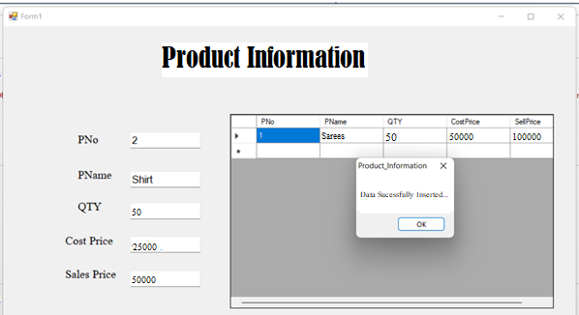

|  |
| --- |
| 1. Create VB.NET application to maintain Company Employees Information.Create following table: tblEmployeeInfo(EmpName,City,DOJ,Department,Salary).Design proper form and make necessary validation.Provideinsert,update and dalete facility for above table.Also provide search facility on EmpNo.Gnerate report in DataGridview to View details of those employees who works in Sales department and salary is less than 10000. |

Imports System.Data.SqlClient

Public Class Form1

Dim con AsNewSqlConnection

Dim cmd AsNewSqlCommand

Private Sub Form1_Load(ByVal sender AsSystem.Object, ByVal e AsSystem.EventArgs) Handles MyBase.Load

Try

con.ConnectionString = "Data Source=.\SQLEXPRESS;AttachDbFilename=C:VBNET\Practical\p3\p3\Database1.mdf;Integrated Security=True;User Instance=True"

cmd.Connection = con

Catch ex AsException

MsgBox(ex.Message)

End Try

display()

End Sub

Subdisplay()

Try

cmd.CommandText = "select * from tblEmployees"

Dim da AsNewSqlDataAdapter(cmd)

Dim dt AsNewDataTable

da.Fill(dt)

DataGridView1.DataSource = dt

Catch ex AsException

MsgBox(ex.Message)

End Try

End Sub

Private Sub Button1_Click(ByVal sender AsSystem.Object, ByVal e AsSystem.EventArgs) Handles Button1.Click

Try

cmd.CommandText = "insert into tblEmployees values ("&empno.Text&" , '"&empname.Text&"' , '"&empcity.Text&"' , '"&empdoj.Text&"' , '"&empdepartment.Text&"' , "&empsalary.Text&" )"

con.Open()

cmd.ExecuteNonQuery()

con.Close()

MsgBox("Data Sucessfully Inserted…..")

Catch ex AsException

MsgBox(ex.Message)

End Try

display()

End Sub

Private Sub Button3_Click(ByVal sender AsSystem.Object, ByVal e AsSystem.EventArgs) Handles Button3.Click

Try

cmd.CommandText = " delete tblEmployees where EmpNo = "&empno.Text&" "

con.Open()

cmd.ExecuteNonQuery()

con.Close()

MsgBox("Data Sucessfully Deleted…..")

Catch ex AsException

MsgBox(ex.Message)

End Try

display()

End Sub

Private Sub Button2_Click(ByVal sender AsSystem.Object, ByVal e AsSystem.EventArgs) Handles Button2.Click

Try

cmd.CommandText = " update tblEmployees set EmpName = '"&empname.Text&"' , City = '"&empcity.Text&"' , DOJ='"&empdoj.Text&"' , Department='"&empdepartment.Text&"' , Salary="&empsalary.Text&" where EmpNo = "&empno.Text&" "

con.Open()

cmd.ExecuteNonQuery()

con.Close()

MsgBox("Data Sucessfully Updated…..")

Catch ex AsException

MsgBox(ex.Message)

End Try

display()

End Sub

End Class

Output:===

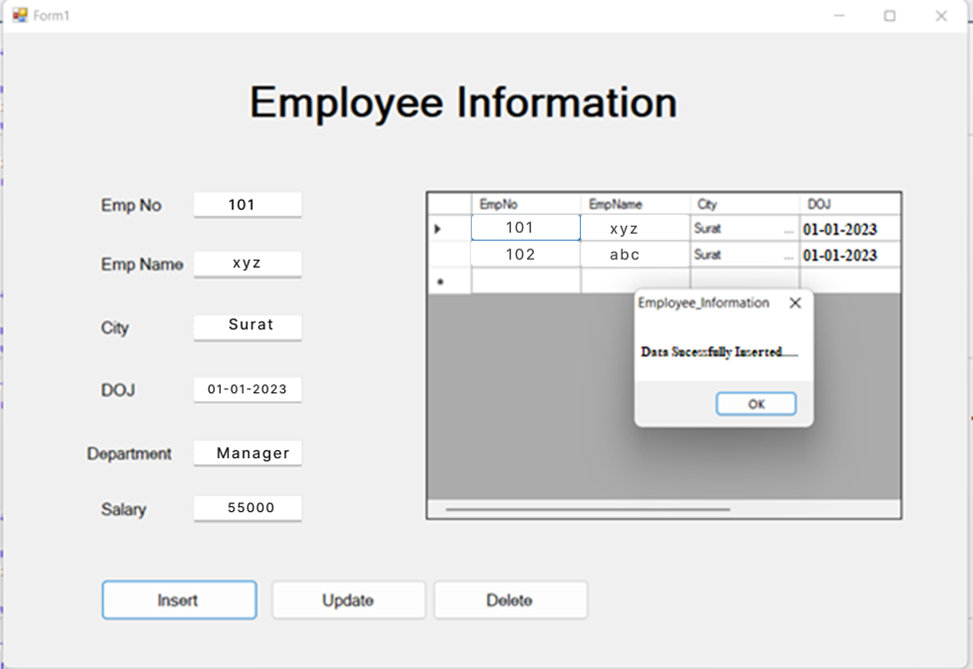

|  |
| --- |
| 1. Create VB.NET application to maintain cricketplayers’ record and display the players’ information according to country wise.Create following table: tblcricketInfo(playerId,PlayerName,Country,No of Matches,No of Runs).Design proper form. Provide insert, update, delete and Display operations on it and also generate report in data gridview. |

ImportsSystem.Data.SqlClient

Public Class Form1

Dim con AsNewSqlConnection

DimcmdAsNewSqlCommand

Private Sub Form1_Load(ByVal sender AsSystem.Object, ByVal e AsSystem.EventArgs) Handles MyBase.Load

Try

con.ConnectionString = "Data Source=.\SQLEXPRESS;AttachDbFilename=C:VBNET\Practical\p4\p4\Database1.mdf;Integrated Security=True;User Instance=True"

cmd.Connection = con

Catch ex AsException

MsgBox(ex.Message)

End Try

ViewData()

End Sub

SubViewData()

Try

cmd.CommandText = "select * from tblPlayers"

Dim da AsNewSqlDataAdapter(cmd)

Dim dt AsNewDataTable

da.Fill(dt)

DataGridView1.DataSource = dt

Catch ex AsException

MsgBox(ex.Message)

End Try

End Sub

Private Sub btninsert_Click(ByVal sender AsSystem.Object, ByVal e AsSystem.EventArgs) Handles btninsert.Click

Try

cmd.CommandText = "insert into tblPlayers values("&txtpid.Text&" , '"&txtpname.Text&"' , '"&txtcountry.Text&"' , "&txtnoofmatch.Text&" , "&txtnoofrun.Text&")"

con.Open()

cmd.ExecuteNonQuery()

con.Close()

MsgBox("Data Sucessfully Inserted")

Catch ex AsException

MsgBox(ex.Message)

End Try

ViewData()

End Sub

Private Sub btnupdate_Click(ByVal sender AsSystem.Object, ByVal e AsSystem.EventArgs) Handles btnupdate.Click

Try

cmd.CommandText = "update tblPlayers set PlayerName='"&txtpname.Text&"' , Country='"&txtcountry.Text&"' , NoOfMatches="&txtnoofmatch.Text&" , NoOfRuns="&txtnoofrun.Text&" where PlayerID="&txtpid.Text&" "

con.Open()

cmd.ExecuteNonQuery()

con.Close()

MsgBox("Data Sucessfully Updated")

Catch ex AsException

MsgBox(ex.Message)

End Try

ViewData()

End Sub

Private Sub btndelete_Click(ByVal sender AsSystem.Object, ByVal e AsSystem.EventArgs) Handles btndelete.Click

Try

cmd.CommandText = "delete tblPlayers where PlayerID="&txtpid.Text&" "

con.Open()

cmd.ExecuteNonQuery()

con.Close()

MsgBox("Data Sucessfully Deleted")

Catch ex AsException

MsgBox(ex.Message)

End Try

ViewData()

End Sub

End Class

Output:===

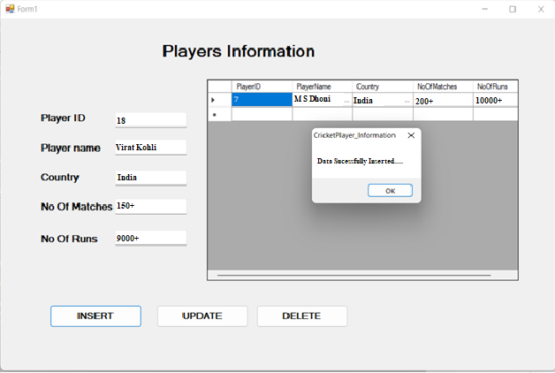

|  |
| --- |
| 1. Create VB.NET application to maintain students Information. Create following table (April/May 2017) Tblstudent(RollNo, Name, Markl, Mark2, Mark3) Design proper form and make necessary validation. Provide insert, update and delete operation for above table. Generate report in DataGridView to display student information that gets percentage greater than 75%. |

ImportsSystem.Data.SqlClient

Public Class Form1

Dim con AsNewSqlConnection

DimcmdAsNewSqlCommand

Private Sub Form1_Load(ByVal sender AsSystem.Object, ByVal e AsSystem.EventArgs) Handles MyBase.Load

Try

con.ConnectionString = "Data Source=.\SQLEXPRESS;AttachDbFilename=C:VBNET\Practical\p5\p5\Database1.mdf;Integrated Security=True;User Instance=True"

cmd.Connection = con

Catch ex AsException

MsgBox(ex.Message)

End Try

Display()

End Sub

Sub Display()

Try

cmd.CommandText = "select * from tblStudent"

Dim da AsNewSqlDataAdapter(cmd)

Dim dt AsNewDataTable

da.Fill(dt)

DataGridView1.DataSource = dt

Catch ex AsException

MsgBox(ex.Message)

End Try

End Sub

Private Sub btninsert_Click(ByVal sender AsSystem.Object, ByVal e AsSystem.EventArgs) Handles btninsert.Click

Try

cmd.CommandText = "insert into tblStudent values("&txtrno.Text&" , '"&txtname.Text&"' , "& txtmarks1.Text &" , "& txtmarks2.Text &" , "& txtmarks3.Text &")"

con.Open()

cmd.ExecuteNonQuery()

con.Close()

MsgBox("Data Sucessfully Inserted")

Catch ex AsException

MsgBox(ex.Message)

End Try

Display()

End Sub

Private Sub btnupdate_Click(ByVal sender AsSystem.Object, ByVal e AsSystem.EventArgs) Handles btnupdate.Click

Try

cmd.CommandText = "update tblStudent set Name='"&txtname.Text&"' , Marks1="& txtmarks1.Text &" , Marks2="& txtmarks2.Text &" , Marks3="& txtmarks3.Text &" where RollNo="&txtrno.Text&" "

con.Open()

cmd.ExecuteNonQuery()

con.Close()

MsgBox("Data Sucessfully Updated")

Catch ex AsException

MsgBox(ex.Message)

End Try

Display()

End Sub

Private Sub btndelete_Click(ByVal sender AsSystem.Object, ByVal e AsSystem.EventArgs) Handles btndelete.Click

Try

cmd.CommandText = "delete tblStudent where RollNo="&txtrno.Text&" "

con.Open()

cmd.ExecuteNonQuery()

con.Close()

MsgBox("Data Sucessfully Deleted")

Catch ex AsException

MsgBox(ex.Message)

End Try

Display()

End Sub

End Class

Output:===

